FA1 Report

FA1 Report
- Student Name: Prakhar Sharma
- Candidate Registration Number: 1000260
- CRS Name: Artificial Intelligence
- Course ID: IADAI204
- Course Name: The Art of Storytelling with Data
- School Name: Ryan Global School, Kharghar
Project Title: Airbnb Urban Tourism Data Dashboard
Github Link:
Tableau Link: https://public.tableau.com/views/Airbnb_Urban_Tourism_Dashboard/Dashboard1?:language=en-US&:sid=&:redirect=auth&:display_count=n&:origin=viz_share_link

1. Introduction
This project focuses on storytelling with data using an Airbnb Urban Tourism dataset. The main aim of the project is to analyze tourism patterns, pricing trends, availability, and popularity of Airbnb listings across different cities through an interactive dashboard.
In today’s digital world, data visualization helps us understand complex information easily. By using visual charts and maps, we can convert raw data into meaningful insights. For this project, I created a data-driven dashboard using Tableau Public to present clear and engaging insights.
The purpose of this project is to:
- Understand Airbnb listing trends
- Analyze price and review patterns
- Study availability across areas
- Present findings through data storytelling

2. Data Understanding
The dataset used in this project is based on Airbnb urban tourism data. It contains information about listings, prices, reviews, room types, and availability in different cities.

Key Fields Used:
- City
- Price
- Number of Reviews
- Room Type
- Availability (365 days)
- Neighbourhood Area
- Listing ID
Before creating the dashboard, the dataset was cleaned and organized inside Tableau. Filters such as City and Room Type were added to make the dashboard interactive and user-friendly.
This helped in:
- Removing confusion in data
- Making charts more accurate
- Improving overall storytelling clarity

3. Dashboard Design and Visualization Explanation
The dashboard was designed to follow a storytelling structure:
Data → Analysis → Insights → Action
Each chart was created to answer a specific question.

3.1 Listings per City
This bar chart shows the total number of Airbnb listings available in each city.
It helps to understand which cities have the highest tourism activity and listing concentration.
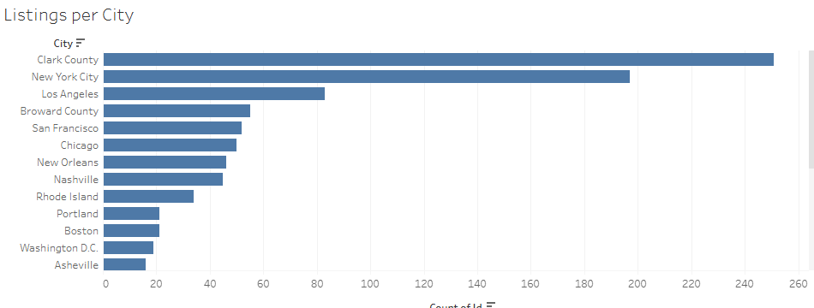

3.2 Price vs Reviews
This scatter plot compares the price of listings with the number of reviews.
It helps to identify whether cheaper listings receive more reviews and popularity.
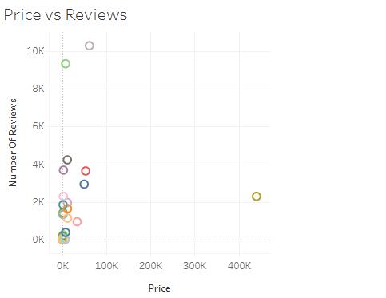

3.3 Reviews by City
This visualization shows the total number of reviews for listings in each city.
It reflects customer engagement and popularity of Airbnb properties in different locations.
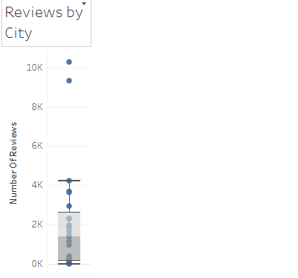

3.4 Price Distribution
This chart displays how prices are distributed across listings.
It helps in understanding whether most listings are budget-friendly or premium.
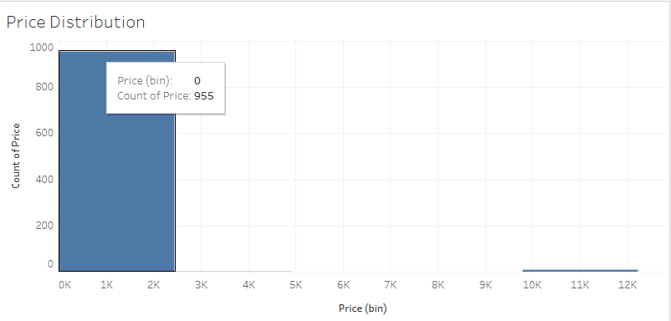

3.5 Popularity Map
The map visualization shows geographic distribution of listings.
It helps to identify tourism hotspots and high-demand locations visually.
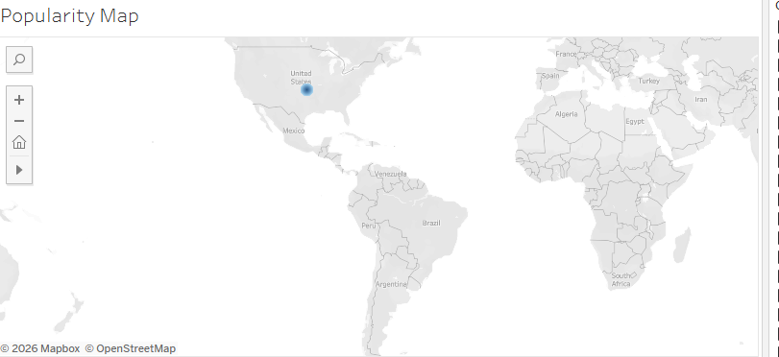

3.6 Availability by Area
This chart shows the average availability of listings in different neighbourhoods.
It indicates supply levels and booking patterns.
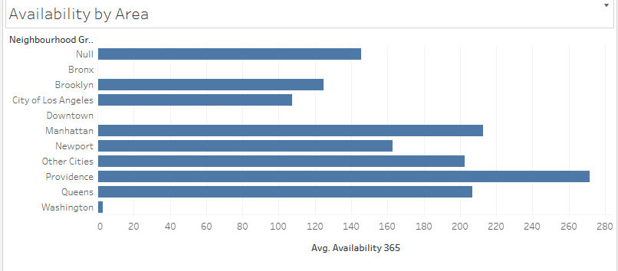

3.7 Room Type Distribution
This bar chart displays the count of different room types such as:
- Entire Home
- Private Room
- Hotel Room
It helps understand customer accommodation preferences.
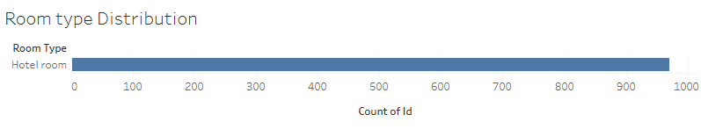

4. Storytelling Approach (Storyboard Integration)
The storyboard for this project was structured into four main stages:

4.1 Data
Raw Airbnb dataset was collected and prepared for analysis.

4.2 Analysis
Multiple charts and filters were used to explore patterns in price, reviews, and availability.

4.3 Insights
Visual patterns helped in identifying key tourism and pricing trends.

4.4 Action
The dashboard provides decision-making support for:
- Tourists
- Hosts
- Urban tourism planners
This storytelling approach made the dashboard more meaningful instead of just displaying charts.

5. Key Insights from the Dashboard
From the analysis, several important insights were discovered:
- Some cities have significantly higher Airbnb listings than others
- Listings with lower prices tend to receive more reviews
- Certain neighbourhoods show higher availability, indicating lower demand
- Hotel rooms and private rooms are more commonly listed than luxury stays
- Popular areas appear clearly on the map visualization
These insights show how data visualization helps in understanding tourism behaviour.

6. Tools and Techniques Used

Tool Used:
- Tableau Public (for dashboard creation)

Techniques Applied:
- Data Filtering (City, Room Type)
- Interactive Dashboard Design
- Data Visualization (Bar charts, Map, Scatter Plot)
- Storyboarding for structured presentation

7. Conclusion
In conclusion, this project successfully demonstrates the importance of storytelling with data. The Airbnb Urban Tourism Dashboard transforms raw data into meaningful visual insights that are easy to understand and analyze.
Through this project, I learned:
- How to create interactive dashboards
- How to convert data into a story
- How visualization improves decision-making
- The importance of clear and structured data presentation
Overall, the dashboard provides valuable insights into pricing trends, listing distribution, and tourism patterns, making it an effective example of data storytelling in real-world applications.

